Make Checks out to : MI VFW Auxiliary
Earmark Check: Vets Returning Home
Send it to: Cathy Sasse, Dept. Treasurer
1117 Michigan Street
Midland, MI. 48640

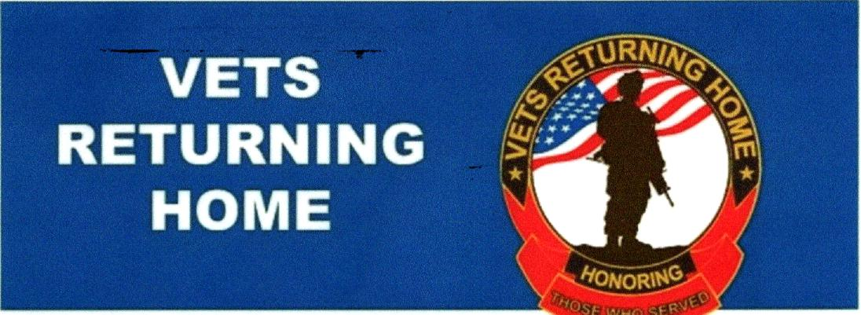
501(C)3 NON-PROFIT CHARITY
Helps homeless veterans in crisis
reclaim independence
Find us on:
facebook.
- Volunteer operated 11,000 square foot facility with (43) beds and commercial kitchen.
- Provide a stable and sober living environment to veterans in crisis.
- On-site services including employment readiness training, aid with job placement.
disability benefit connection, legal support and life skills training.
- Fully furnished apartments.
- Community support both physical and financial has been vital to our ability to
continue our mission. Vets Returning Home receives NO government funding.
- VRH has successfully transitioned on average 250 veterans a year back into
society as fully functioning community members.
www.vetsreturninghome.org

